Login to GitHub. Cougarpainting:salemhighschoolrulz. Go to bsw975/cougarpainting (top left)

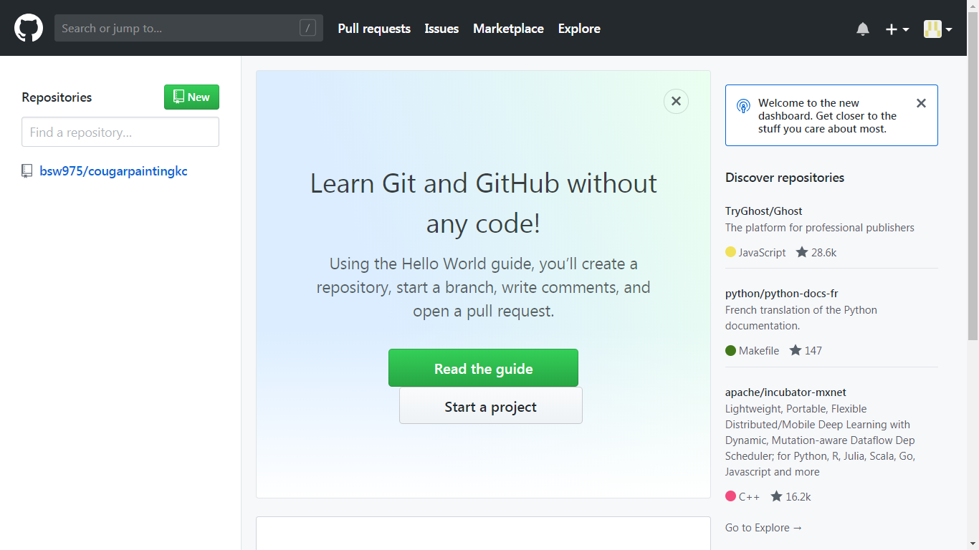

Open index.html

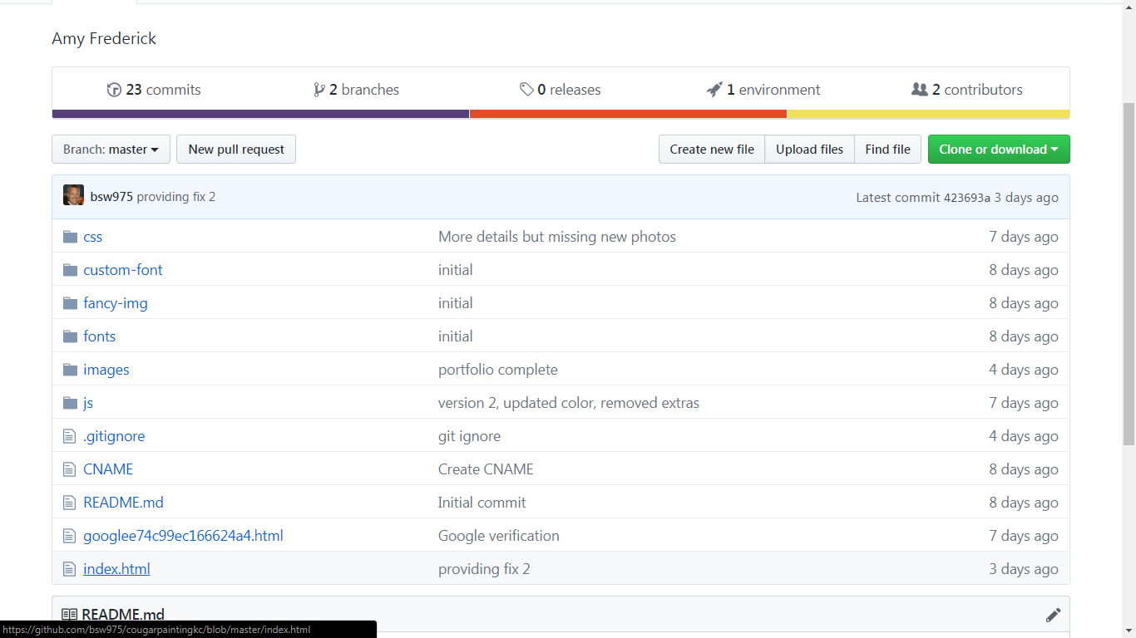

Click edit this file (middle right). Then you’re in The Matrix.

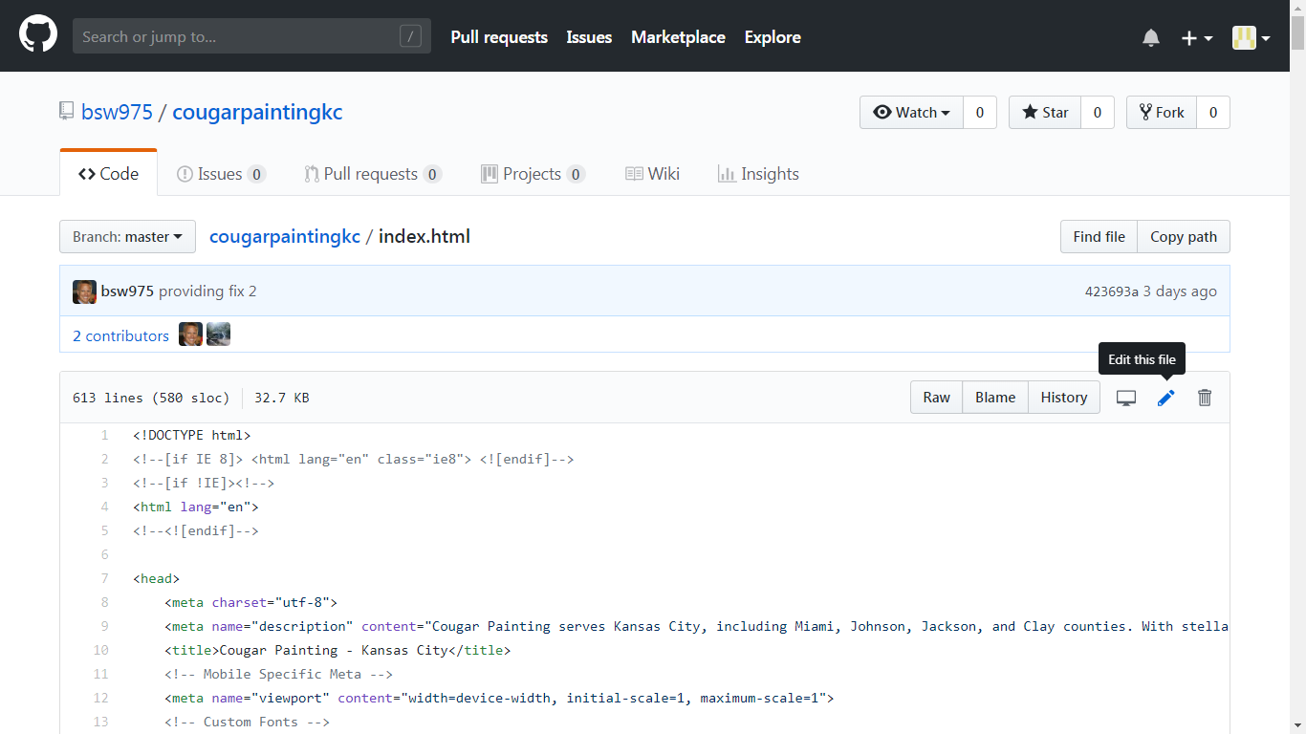

The portfolio is here. Add ‘height-2’ and/or ‘width-2’ to adjust them.:

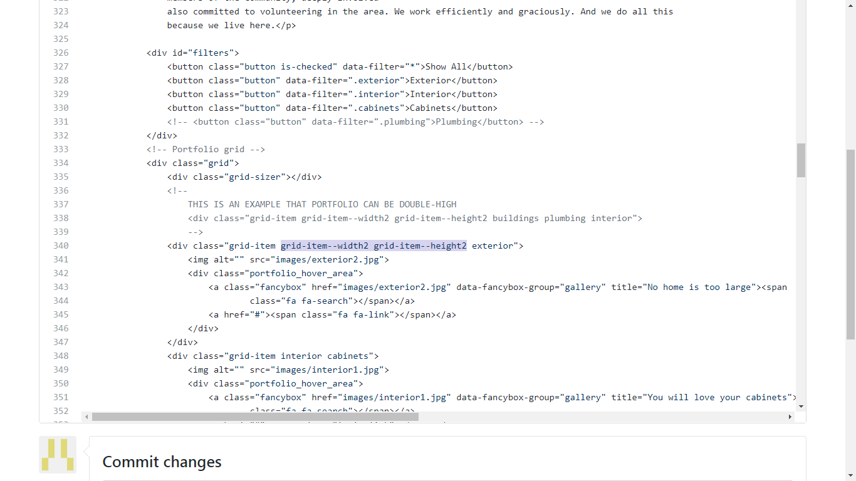

Once done enter a short bit about changes made, then click Commit changes

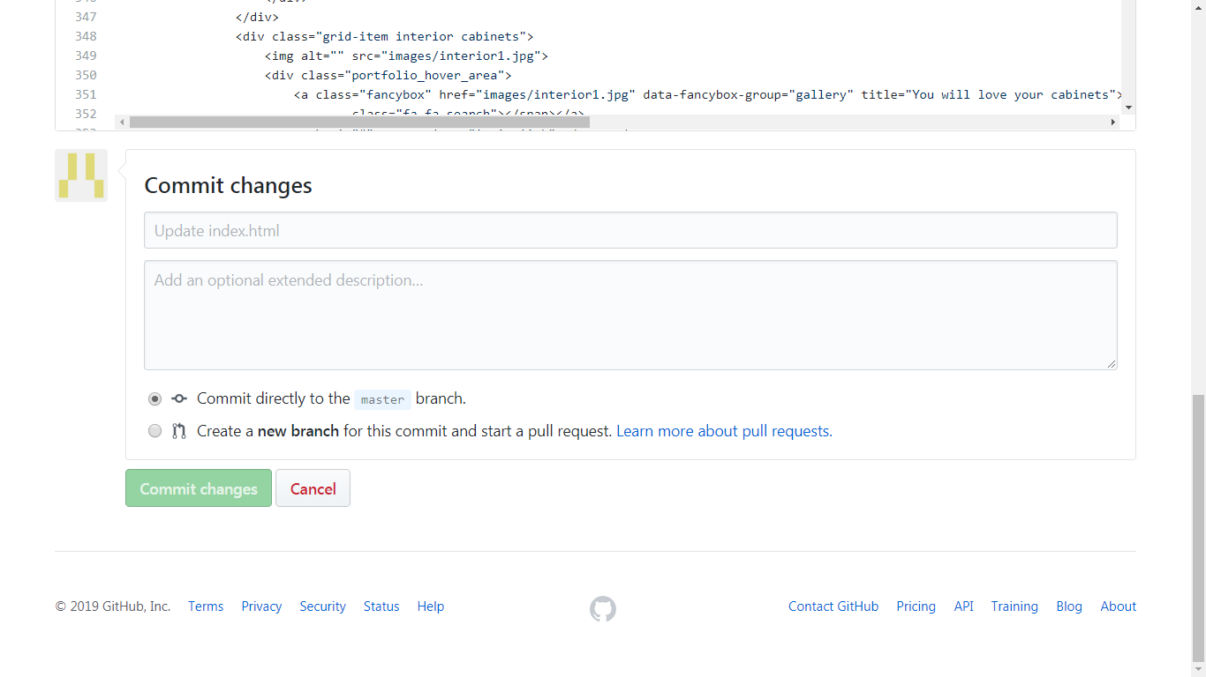

Images are here. Add or edit as needed. The picture’s filename is only a guide. For the portfolio filter to work, you have to edit it under the div section in index.html

